Rahma Abdel-Aty Hassan Mohamed Alwaleed
Graduated conversation department
Qena, Faculty of archaeology, South Valley University E_mail: rahma.abdelati@arch.svu.edu.eg

PERSONAL INFORMATION

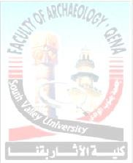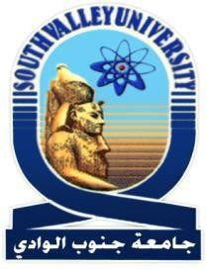Position Nationality Birth Date Religion Marital Status Address

Telephone numbers
Work Mobile FAX
E_mail
Graduation project:
Graduated Egyptian 1/8/1996
Muslim. Single
Conversation Department, Qena faculty of archaeology
South Valley University

096/ 3366850
01023050269
096/ 5211279
rahma.abdelati@arch.svu.edu.eg

The role of nanoparticles in reducing the bio-deterioration on well building

Curriculum vitae of

Rahma Abdel Aty H.M. Alwaleed

EDUCATION AND CERTIFICATION:

BACHELOR (B.SC.)
University Faculty Department Grade Graduation Grade

South Valley University. Faculty of Archaeology. Conversation Department Good, July 2018.
Good (72.3%)

Curriculum vitae of

Rahma Abdel Aty H.M. Alwaleed

2



EXPERIENCE, TRAINING AND SKILLS:

EXPERIENCE & TRAINING:

- Training Course in ethics and professional ethics, Development Center, faculty members and leaders, South Valley University.
- Training Course in quality standards in the educational process, Development Center, faculty members and leaders, South Valley University.
- Training course on E-Content- Information &Communication Technology (ICTC- Trainng), South Valley University.
- Training Course on AutoCad principles &Applications in Archaeology
-

Curriculum vitae of

Rahma Abdel Aty H.M. Alwaleed

SKILLS
COMPUTER SKILLS:
  - Get the ( IC3 ) International Computer Driving License.
  - Good knowledge of using Microsoft office.
  - Good ability to explore the Internet and how to deal with it.
  - Good knowledge Word Processing.
  - Good knowledge of Advanced Power Point.
-. Good knowledge of Photoshop
-.passed the examinations of AutoCAD -
LANGUAGE SKILLS:
- Arabic: Native.
- English: fluently in both speaking and writing and reading listening English.
PERSONAL SKILLS
- Ability to plan, organize and implement different group activities.
- Team player with strong leadership, communication & innovation.
- Extremely organized person.
- Ability to learn when and wherever found.
- Ability to live and/or serve in hardship locations
- Have a good representation & communication skills.
- Very good ability of communicate with people at all level.
I declare that all the above information is true

Thanks for attention.
REFERENCES

Available Upon Request

Curriculum vitae of Rahma Abdel Aty H . M . Alwaleed


